‘SE LINUX’
or
‘Security Enhanced-LINUX’

SE linux is a access control system that is built into the linux kernel. It is used to enforce the resource policy that defines where level of access users programs & services have on a system. Thus, SE linux is a set of kernel modifications and a extra layer of security.
It was originally developed by the United States National Security Agency (NSA).

“/etc/Selinux/config” is the main configuration file of Selinux.

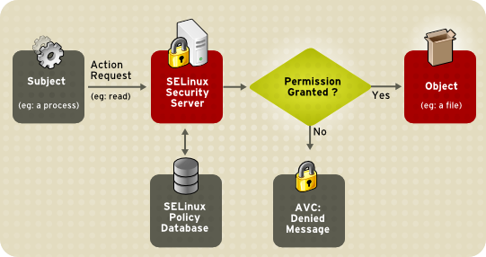
Selinux works on targeted policies which means one policy for a single application. In Linux, we have seen that without execute permission (x) read (r) permission won’t work. And for this we have provide both (r+x) permission toghether but it may result in corruption sometimes.
So, here Selinux declares that exactly what actions and accesses are required to be given for each binary configuration file, data file, binary executable. These are referred as targeted policies.

We have already heard about Permissions, special permissions (SGID, STICKY BIT) & ACL too. Like this SELINUX is also a type of Pro or Advanced Security feature to deal with most of the security issues. But it can’t deal with all the security issues.

Like everything Selinux also have some demerits like complexity & critical in use too. But we can turn it off for that particular service also.
Selinux is in which state can be checked by commands & there are 3 different stages of selinux :

- ENFORCING : In this mode, selinux “denies access” based on a selinux policy rules.
Command for getting into this mode is “setenforce 1” (where 1 is used to make mode Enforced) and to check the current mode use “getenforce” command.

- PERMISSIVE : In this, selinux “doesn’t deny” access but denials are locked for actions that would have been denied if running & enforcing. So, here it is active but only records the voilation of rules. Command to get into this mode is “setenforce 0” (where 0 makes the selinux mode permissive).
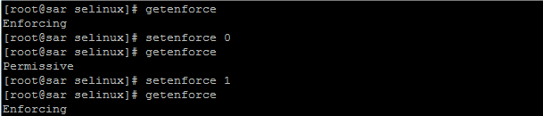
- DISABLED : Here the selinux policy is totally disbaled. No denials and no record.
Selinux policy all information can be checked by the command : SETSTATUS
“Alternative method is by altering the entries in /etc/seliux/config file”.

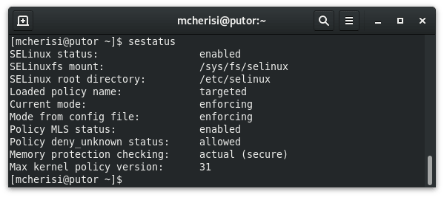

- Selinux protects users data from system services because selinux provides object based security layer called Mandatory Access Control.

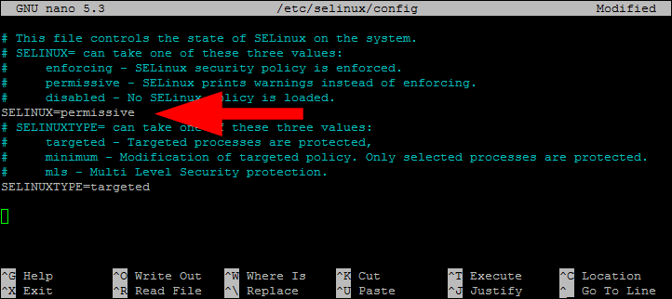
There is a another method of changing this mode of Selinux i.e., by editing /etc/selinux/config file.

Usually there are two types of access control : MAC & DAC

MAC : Mandatory Access Control – Selinux is a MAC working system and it is most secured access. Decisions are based on objects and tasks particularly. It is used in military, government and intelligence. Users will be restricted based on their power and level hierarchy. Difficult & complex to implement.

DAC : Discretionary Access Control – Linux is a DAC working system and it is less secured access than MAC. Here the owner can determine the access and privileges and so can restrict the resources based on identity of the users. Decisions are based on user ID & ownership. Less complex than MAC & easy to use.

SELINUX CONTEXT : Every file, proccess, directory & port has a special security label called as selinux context. Where CONTEXT is a name used by selinux policy to determine whether a process can access a file or directory or port. Context contains additional information such as user, role, type, level and sensitivity. So, access control decisions are based on this context.
To check the context of a file, directory, process or port use -Z option.
Every file/dir created has a seperate context of that place wherever it is created.
Context check command on cli : “ls -Zd for both files & directories” and “ls -Z for files only”.

The default context file of selinux is ‘/etc/selinux/{SELINUXTYPE}/contexts/default_contexts’.

Every place in linux has a different Selinux context like,
For a Web server = httpd_t,
For a Web server port = httpd_port_t,
For /tmp = tmp_t,
For /mnt = mnt_t,
For /var/www/html = httpd_sys_content_t, here /var/www/html is the DOCUMENT ROOT or ROOT DIRECTORY OF HTTPD (web server).

Changing or controlling Selinux file context :
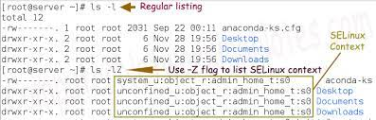
- Semanage fcontext command - It is used to change the SELinux context of files.
“semanage fcontext (-a) + (-t) + (context) + (absolute path of file/dir)” command to change the file type to the new context type. The -a option adds a new record, and the -t option defines a type (context). Note: running this command does not directly change the type - file is still labeled with the old context.
The /usr/sbin/semanage fcontext -a -t context file or dir path command adds the following entry to /etc/selinux/targeted/contexts/files/file_contexts.local.
Semanage fcontext -l = to list.

- Restorecon command – It is used for modifying the SELinux context of a file or directory.
restorecon -v (absolute path of file/dir) : As the Linux root user, run this command to change the type. Since the semanage command added an entry to file.contexts.local for file/dir the restorecon command changes the type to latest contexts.

“Adjusting SElinux policy with BOOLEANS”
- BOOLEANS – Booleans are the policies that enables or give access to runtime customization of selinux policy.
- SELINUX BOOLEANS - They are the swithces that change the rules or behaviour of selinux policy.

COMMANDS FOR BOOLEANS :

- Getsebool – Getsebool -a : This command is for local user. Here you get the state of booleans.
- Setsebool : It is used to modify booleans.
- Setsebool – p : make changes persistently in selinux policy.
- Semanage boolean -l : It is performed by root user for giving description about booleans.

“MONITORING SELINUX VOILATIONS”

The setroubleshoot-server command sends a summary of troubleshooting to /var/log/messages & if there is any voilation in selinux policy then we can find its UUID there and also an audit message in /var/log/audit/audit.log.
sealert is the user interface component (either GUI or command line) to the setroubleshoot system.

Command to get alerts about those voilations :

Sealert -l UUID : It will produce a report of that particular incident with its UUID.
Or
Sealert -a /var/log/audit/audit.log : It produces a report inthis audit.log file. Here you will get all the issues running.
